**US Science Body, India Join Forces To Launch Space Solar Initiative To Meet Energy Needs**

By [Keerthi Mohan](http://www.ibtimes.com/reporters/keerthi-mohan)

on June 12 2013 4:46 AM

The National Space Society, NSS, and India will work together to create an international organization to harness solar power in to meet the world's ever-surging energy requirements.

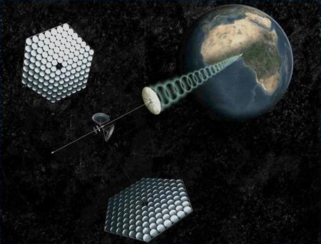

An artist's rendering provided by SpaceWorks Engineering, Inc. shows a modern design for an orbital power plant beaming renewable energy to the developing world in this image released to Reuters on November 12, 2011. Reuters

"Space solar power," which could be the key to a livable planet Earth will also help mitigate climate change, A. P. J. Abdul Kalam, an eminent scientist and former Indian President, and Mark Hopkins, chairman of the NSS's executive committee, said in a joint [statement](http://www.nss.org/news/releases/NSS_Release_20130610_LivableEarth.html) to the media.

“Time has arrived for us to together attempt to give a direction and momentum to this movement to realize space solar power and its enabling technologies through international collaboration that can help rebuild our environmentally vulnerable planet,” the duo said in the statement.

The organization will include a global platform to share knowledge about the subject, a virtual library and an international advisory committee.

Related

* [China Proposes Space Solar Power Collaboration With India](http://www.ibtimes.com/china-proposes-space-solar-power-collaboration-india-858330)

They announced that a clear plan of action will be charted within a year to market the idea to G8 or G20 nations. Core members of the international organization will be from nations that are already exploring the idea of harvesting energy from space such as the U.S., India, Japan and U.K.

"We hope our international collaborative mission will act as a catalyst for a livable planet which will promote prosperity and peaceful relations within and between nations," the statement said.

According to an [ExtremeTech](http://www.extremetech.com/extreme/149638-beam-me-down-scotty-space-based-solar-power-finally-comes-of-age) report, Russia and China have already initiated work on setting up a Space-Based Solar Plant, or SBSP. Roscosmos, the Russian space agency, has a working 100-kilowatt SBSP prototype that is yet to be launched, and China plans to put up a 100-kilowatt SBSP by 2025, the report said.