<https://www.forbes.com/sites/scottsnowden/2019/03/05/china-plans-to-build-the-worlds-first-solar-power-station-in-space/#115d25775c94>

[Editor's Pick](https://www.forbes.com/editors-picks)23,125 viewsMar 5, 2019, 10:22am

**China Plans To Build The World's First Solar Power Station In Space**

[](https://www.forbes.com/sites/scottsnowden/)

[Scott Snowden](https://www.forbes.com/sites/scottsnowden/) Contributor

[Science](https://www.forbes.com/science)

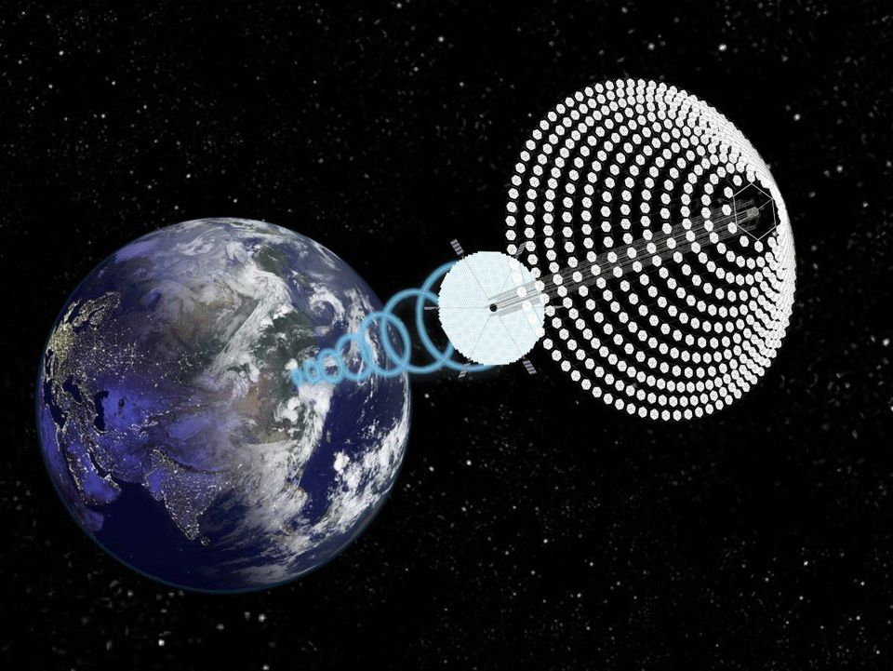

Proposed space solar array SPS-ALPHA, image and concept courtesy John C. Mankins

John C. Mankins

China is planning to build the world's first solar power station in space to provide "inexhaustible clean energy" according [to a story](http://www.stdaily.com/index/kejixinwen/2019-02/14/content_750019.shtml) in *Science and Technology Daily,*the official newspaper of China's Ministry of Science and Technology.

Pang Zhihao, from the China Academy of Space Technology said that a space solar power system orbiting the Earth at an altitude of 36,000 kilometers could tap the energy of the sun's rays without disruption from atmospheric conditions or loss of sunlight at night.

They claim to be already testing the technology and intend to build the station by 2050.

Xie Gengxin, deputy head of the Chongqing Collaborative Innovation Research Institute for Civil-Military Integration in Southwestern China, told the [*China Daily*](http://www.chinadaily.com.cn/a/201902/27/WS5c75c8b3a3106c65c34eb8e3.html) newspaper that a testing facility in Chongqing's Bishan district is being built that will be used to test the theoretical viability of a space-based solar power station.

Today In: [Innovation](https://www.forbes.com/science)

The 33 acre test facility will develop space transmission technologies while studying the effect of microwaves beamed back to Earth on living organisms. The initial investment of 100 million yuan ($15 million) will be made by the Bishan district government and construction could take up to two years, but once it begins operations, scientists and engineers will use tethered balloons equipped with solar panels to verify microwave transmission technologies.

"We plan to launch four to six tethered balloons from the testing base and connect them with each other to set up a network at an altitude of around 1,000 meters," said Gengxin. "These balloons will collect sunlight and convert solar energy to microwave before beaming it back to Earth. Receiving stations on the ground will convert such microwaves to electricity and distribute it to a grid."

**PROMOTED**

Mitsubishi Heavy Industries BrandVoice  | Paid Program

**Oil & Gas Outlook – Embracing Change From Now To 2040**

First proposed in 1968 by aerospace engineer Peter Glaser, the concept of a power-generating platform in geostationary orbit has been a popular idea among scientists, but has seen little in terms of development due to technological and financial hurdles. These notions may sound farfetched, but the space agencies of both China and Japan are taking the ideas that were once just the stuff of science fiction very seriously.

Plans to develop an orbital array of photovoltaic dishes [were announced](https://phys.org/news/2009-11-japan-eyes-solar-station-space.html) in Japan some time ago and according to [CNN](https://us.cnn.com/2019/03/03/asia/china-plans-solar-power-in-space-intl/index.html), Beijing is pledging to invest 2.5 trillion yuan ($367 billion) in renewable power generation – solar, wind, hydro and nuclear – by 2020, indicating China's willingness to invest in advanced concepts.

Follow me on [Twitter](https://www.twitter.com/https:/twitter.com/lorumipsum).

[](https://www.forbes.com/sites/scottsnowden/)

[Scott Snowden](https://www.forbes.com/sites/scottsnowden/)

Scott has written about science and technology for 20 years for various publications around the world, including the BBC, NBC, the FT and Space.com. He covers environmen...

* Print
* [Site Feedback](mailto:feedback@forbes.com)
* [Tips](https://www.forbes.com/tips/)
* [Corrections](mailto:corrections@forbes.com?subject=Report%20Correction%3A%20Scott%20Snowden&body=Reporting%20Correction%20for%3A%0A%0ATitle%3A%20China%20Plans%20To%20Build%20The%20World's%20First%20Solar%20Power%20Station%20In%20Space%0AAuthor%3A%20Scott%20Snowden%0AURL%3A%20https%3A%2F%2Fwww.forbes.com%2Fsites%2Fscottsnowden%2F2019%2F03%2F05%2Fchina-plans-to-build-the-worlds-first-solar-power-station-in-space%2F%0A%0A--%0A%0AYour%20Name%3A%0ACorrection%20Request%3A%0A%0A--%0A%0AThank%20you%20for%20reporting%20a%20correction.%20Forbes%20staff%20will%20review%20your%20concern%20shortly.)
* [Reprints & Permissions](https://www.parsintl.com/publication/forbes/)
* [Terms](https://www.forbes.com/terms/)
* [Privacy](https://www.forbes.com/fdc/privacy.html)
* ©2019 Forbes Media LLC. All Rights Reserved.
* [AdChoices](http://preferences-mgr.truste.com/?pid=forbes01)

Current Time 0:23

/

Duration 0:30

9,666 viewsNov 7, 2019, 02:32pm

**This Japanese Business Philosophy Is Unlocking Innovation In Aviation**

[](http://www.forbes.com/sites/mitsubishiheavyindustries/)

[Takaoki Niwa](https://www.forbes.com/sites/mitsubishiheavyindustries/people/takaokiniwa/) Brand Contributor

[Mitsubishi Heavy Industries](http://www.forbes.com/sites/mitsubishiheavyindustries/) BRANDVOICE | Paid Program

[Business](https://www.forbes.com/business)

[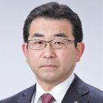Takaoki Niwa](https://www.forbes.com/sites/mitsubishiheavyindustries/people/takaokiniwa/)

With nearly four decades of experience as both an engineer and a leader for Mitsubishi Heavy Industries, Ltd. (MHI), Takaoki Niwa began his career in 1980 as a manufactu...

* Print
* [Site Feedback](mailto:feedback@forbes.com)
* [Tips](https://www.forbes.com/tips/)
* [Corrections](mailto:corrections@forbes.com?subject=Report%20Correction%3A%20Takaoki%20Niwa&body=Reporting%20Correction%20for%3A%0A%0ATitle%3A%20This%20Japanese%20Business%20Philosophy%20Is%20Unlocking%20Innovation%20In%20Aviation%0AAuthor%3A%20Takaoki%20Niwa%0AURL%3A%20https%3A%2F%2Fwww.forbes.com%2Fsites%2Fmitsubishiheavyindustries%2F2019%2F11%2F07%2Fthis-japanese-business-philosophy-is-unlocking-innovation-in-aviation%2F%0A%0A--%0A%0AYour%20Name%3A%0ACorrection%20Request%3A%0A%0A--%0A%0AThank%20you%20for%20reporting%20a%20correction.%20Forbes%20staff%20will%20review%20your%20concern%20shortly.)
* [Reprints & Permissions](https://www.parsintl.com/publication/forbes/)
* [Terms](https://www.forbes.com/terms/)
* [Privacy](https://www.forbes.com/fdc/privacy.html)
* ©2019 Forbes Media LLC. All Rights Reserved.
* [AdChoices](http://preferences-mgr.truste.com/?pid=forbes01)

Cookie Preference